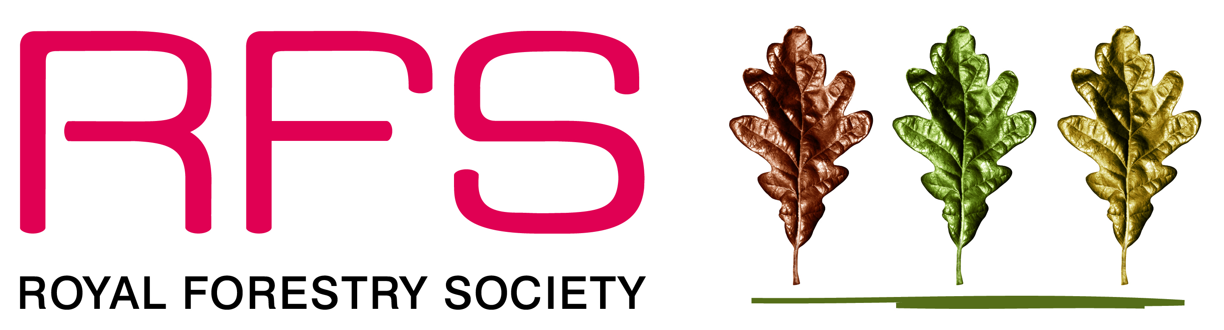
PRESS INFORMATION
June 2013

Media contacts: Wendy Necar, RFS Communications Officer,
01926 421679/07973 523168, email communications@rfs.org.uk

Pictured: Northwood. A haven of tranquility on what was once a derelict site

Northwood named Urban Forest 2013!

Northwood estate in Knowsley has won a Royal Forestry Society (RFS) award for excellence thanks to the neighbourhood’s recent green transformation.

The award recognises the rejuvenation of the Northwood Forest Hills – part of The Mersey Forest - as well as the community scheme to plant over 200 street trees along the streets that link Northwood Forest Hills with The Rough - a more formal park about half a mile to the south.

The work has led to Northwood being named top Urban Forest 2013 in the North West and West Midlands region in the Royal Forestry Society's Excellence in Forestry Awards held in association with the Forestry Commission.

Judges Les Starling and Trefor Thompson praised Northwood Forest Hills – created on an overgrown and little-used green space on the edge of the estate – for the way it has transformed the area and helped bring the local community together.

They said: "It has been transformed into a delightful wooded green space with a mosaic of water and wetland features, grasslands and wildflower meadows, overseen by an active residents group known as the 'Northwood Mums' who take a hard line on any antisocial behaviour!"

Keith Jones, Area Director, the Forestry Commission, said:"The transformation of Northwood Forest Hills, and the network of new street trees that connect the site to the wider community, are both excellent examples of how trees and woodlands can bring real benefit to urban areas. The site has been created with the community at its heart, and I’m sure it will offer the local people of Kirby a place for recreation, exercise, relaxation and community activity for many years to come.”

Cllr Eddie Connor, Cabinet Member for Leisure, Community and Culture for Knowsley Council, said:
“We are delighted to have secured such a prestigious award within our local community.
The woodland project and street tree programme has completely transformed that part of our community and I’m proud to see that the community has received such recognition for its efforts.

“It wouldn’t have been possible without the hard work of local residents and a whole range of partners and funders.”

The forestry and infrastructure development works carried out between 2010-13 were supported by Northwood Community Allotments, Knowsley Council, the Mersey Forest, Groundwork, Merseyside Environmental Advisory Services and 2020 Knowsley, with funding secured through the BIS ‘Setting the Scene for Growth’ Fund, Big Lottery Fund ‘Community Spaces’, Marks & Spencer ‘Greener Living Spaces’ Fund, Knowsley Neighbourhood Renewal Fund, Knowsley Housing Trust and the Forestry Commission.

The street tree planting was carried out as part of The Mersey Forest’s Green Streets programme, which saw local residents helping to choose which species of trees they would like to see on their streets,

The Award will be presented by Keith Jones of the Forestry Commission at an event at Wythenshawe Park in Manchester on 3 July.

The RFS is dedicated to promoting the wise management of trees and woodlands. It has 21 Divisions and organises events across England, Wales and Northern Ireland to help share knowledge. To find out more and how to join go to www.rfs.org.uk

Notes for editors

The Royal Forestry Society (RFS) was founded in 1882 and now has approaching 4,000 members who include woodland owners, land managers, foresters, students, keen amateurs, arborists, landscapers, timber users and ecologists.

We promote the wise management of woodlands through formal and recognised qualifications; by the exchange of ideas and networking of experiences; by providing information to the public and through our website www.rfs.org.uk

The Mersey Forest
The Mersey Forest is a growing network of woodlands and green spaces spread across Cheshire and Merseyside, which has been creating 'woodlands on your doorstep' for 20 years.

The Forest is one of the leading environmental regeneration initiatives in the North West. Through community and partnership working, we have planted more than 8 million trees - equivalent to five new trees for every person living within the Forest area.

The Forest helps our towns and cities adapt to climate change and has won the Brian Redhead Award for Environmental Sustainability, creates woodlands that 20% of local people visit at least once a week, and by improving the image of our towns and cities sets the scene for growth within the region's £98 billion economy.

We achieve all of this and more through our partnership of local authorities, landowners, the Forestry Commission, Natural England and businesses including United Utilities.

www.merseyforest.org.uk

