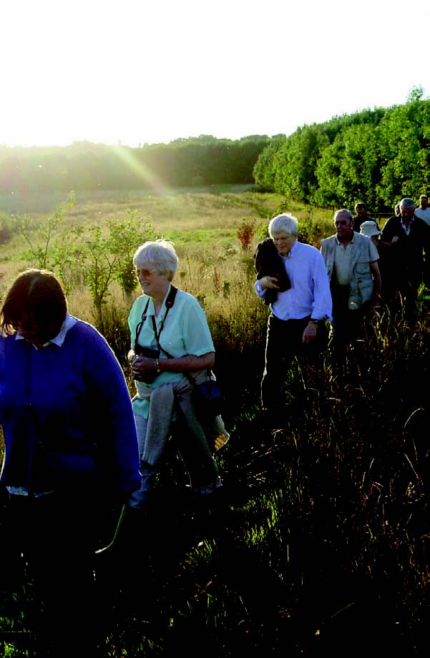
The Newlands scheme is a partnership between the North West Development Agency and the Forestry Commission. It is responding to local and regional economic and social needs by transforming brownﬁeld sites into thriving, durable community woodlands. Brockholes is being developed as a wetland and woodland nature reserve by the Lancashire Wildlife Trust and the Forestry Commission. New features will be created in the near future (January 2009).
Some improvements are underway but there is much work still pending. The Forestry Commission is keen to know the opinions of local people about the current state of the site and the way forward for the future of Brockholes Wetland and Woodland Nature Reserve.
As such this report needs to be read as a response to the very early stages of Brockholes project as well as feedback on the work that is currently underway. It can also be seen as a window into the local aspirations for the site. To be able to assess what impacts these improvements will have over time, this set of baseline data will be used to compare future data collected about Brockholes. This research was carried out by Pathways Consultancy between June and October 2008.

231 people gave their views All live close to the site, use the site now or would like to use it in the future
This report shows what they said
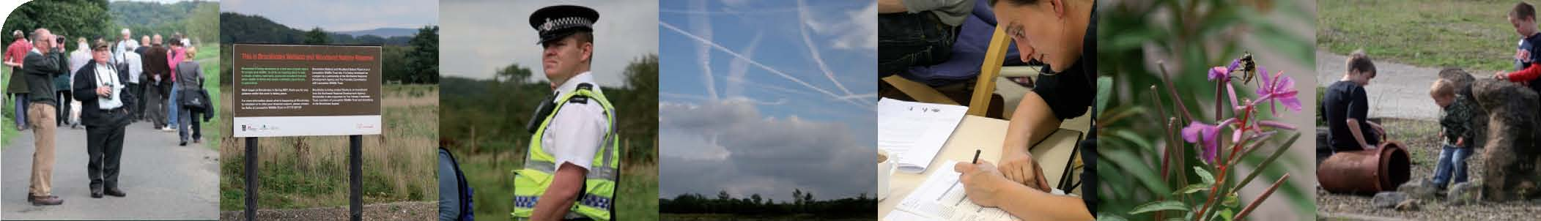

Brockholes Wetland and Woodland Nature Reserve – the story so far...
Brockholes Wetland and Woodland Nature Reserve is one of eight new developments in the North West which are being created by the Forestry Commission as part of the Newlands scheme. Newlands is reclaiming large areas of derelict, underused and neglected land to create thriving community woodlands.
Brockholes is situated next to Junction 31 of the M6. This 106 hectare site was previously farmland that was used for gravel extraction. When this ended in 2005, the site was left as a mosaic of large areas of open water and wetland habitats. Despite the access restrictions in place when it was a working quarry, Brockholes is known as one of Lancashire’s major bird watching sites and people from nearby communities use the area for ﬁshing, walking and cycling.
Under the Newlands scheme, the Lancashire Wildlife Trust was able to buy the site in 2007. The Trust has ambitious plans to develop Brockholes as a nature conservation site of regional and national importance – the hub of a network of wetland sites in the Ribble Valley, a complex of nationally important ancient woodlands and one of the UK’s major salmon rivers, the River Ribble. Proposed visitor facilities could make Brockholes a major conservation destination. Given its location adjacent to the M6, the site is within an hour’s drive of the region’s main towns and it could attract longer distance travellers passing through the area on business or to holiday destinations.
A total of £7.8 million is being invested in Brockholes and processes are already underway to protect and enhance its wildlife value. Special emphasis is on UK priority habitats and those which support UK priority species such as bitterns, otters and water voles. A new visitor centre will ﬂoat on one of the open lagoons at the site. Architects have been appointed following a design competition and building work begins in August 2009. Facilities will include educational and conference facilities; a café and a food outlet selling regional produce.
At the current time public access to the site is problematic because of health and safety issues. People who know the site already use it and the Lancashire Wildlife Trust has started to involve local people on site through regular volunteer opportunities. Wider access is still limited. This is the only Newlands site which will be staffed.
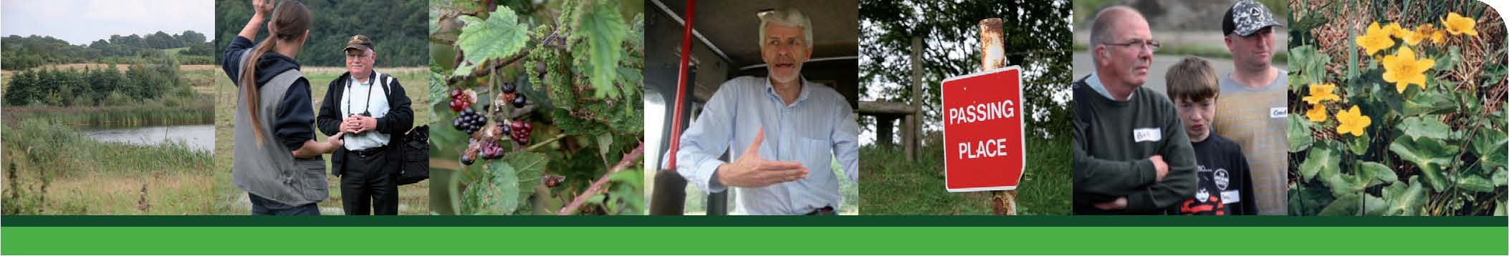

How can we measure the social impact of this new community woodland?
The Forestry Commission is using 17 measures of success that help deﬁne the social impact of new community woodlands. Where a site has had a positive impact it is expected that it will be a focal point for the community and be well known and well used. It will be a safe place that people feel proud of and which helps them be healthy and which contributes to the area’s vibrancy and regeneration. Using the following 17 measures or indicators it will be possible to look at how well a new community woodland is performing – what is working well and what could be improved, both now and in the future.
Brockholes is a successful community resource
- Local people know about the site
- Local people know how to get onto the site
- The site is well used by local people
- Local people know what’s happening on the site

Brockholes helps to improve people’s health and well-being
- The site is used for a wide range of activities
- Children and young people use the site for formal and informal play
- People are gaining health and well-being beneﬁts

Brockholes develops pride in the area and a sense of community

8. Community activities and celebrations take place on the site

9. The site is seen as an asset to the area and something which has increased people’s sense of pride

10. The site contributes to a greener local environment

Brockholes improves the perception of the area’s safety

11. People feel safe on the site

12. There is no rise, or there is a decrease in antisocial behaviour on the site

Brockholes supports the local economy

13. There is an increase in volunteer and employment opportunities for local people

14. The site is valued by local businesses and seen to beneﬁt their work

Brockholes fosters local democracy

15. The management and maintenance is value for money and high quality

16. People feel they can have a say in how the site develops

17. The site contributes to a positive opinion about the work of local agencies and government

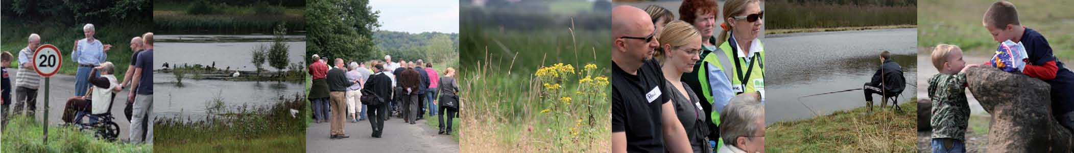
Who gave their views?
The work to gather information for these indicators was carried out by Pathways Consultancy, Manchester. The Pathways team spoke to 231 people in the local area and the quotes used in this report came
from them. The Pathway’s team:
Spent time ‘on the streets’ talking to people: 187 people gave information this way
Researchers worked in locations approximately 10 minutes walking distance or less from Brockholes. They spoke to people as they were out and about and interviewed them using a short questionnaire. Researchers aimed to gather views from a wide range of people and contact details were gathered if people were willing to disclose them.
Interviewed 12 people using the site
Researchers spent a total of two days on Brockholes observing the use of the site and interviewed some people they met while there. They were present from 7.30am to 1.30pm on one week day and one weekend day and from 1.30pm to 7.30pm on a second week day and weekend day. This totals two days of observation that took place on four separate occasions.
Ran a Spaceshaper event: 22 participants gave their views this way
Local residents and representatives of local groups and organisations with an interest or connection to Brockholes were invited to a half-day Spaceshaper event. The event used Spaceshaper – a nationally recognised toolkit developed by CABE Space that helps people measure the quality of open spaces – to structure the discussions around the site and its future. The Spaceshaper questionnaire asks 41 questions about an open space. The answers are grouped under eight headings and used to generate discussions about the quality of the space.
Surveyed 10 local businesses
Researchers interviewed 10 people who owned or worked in businesses close to Brockholes. They were asked what they thought of the site and speciﬁcally what difference they felt it might make to their business.
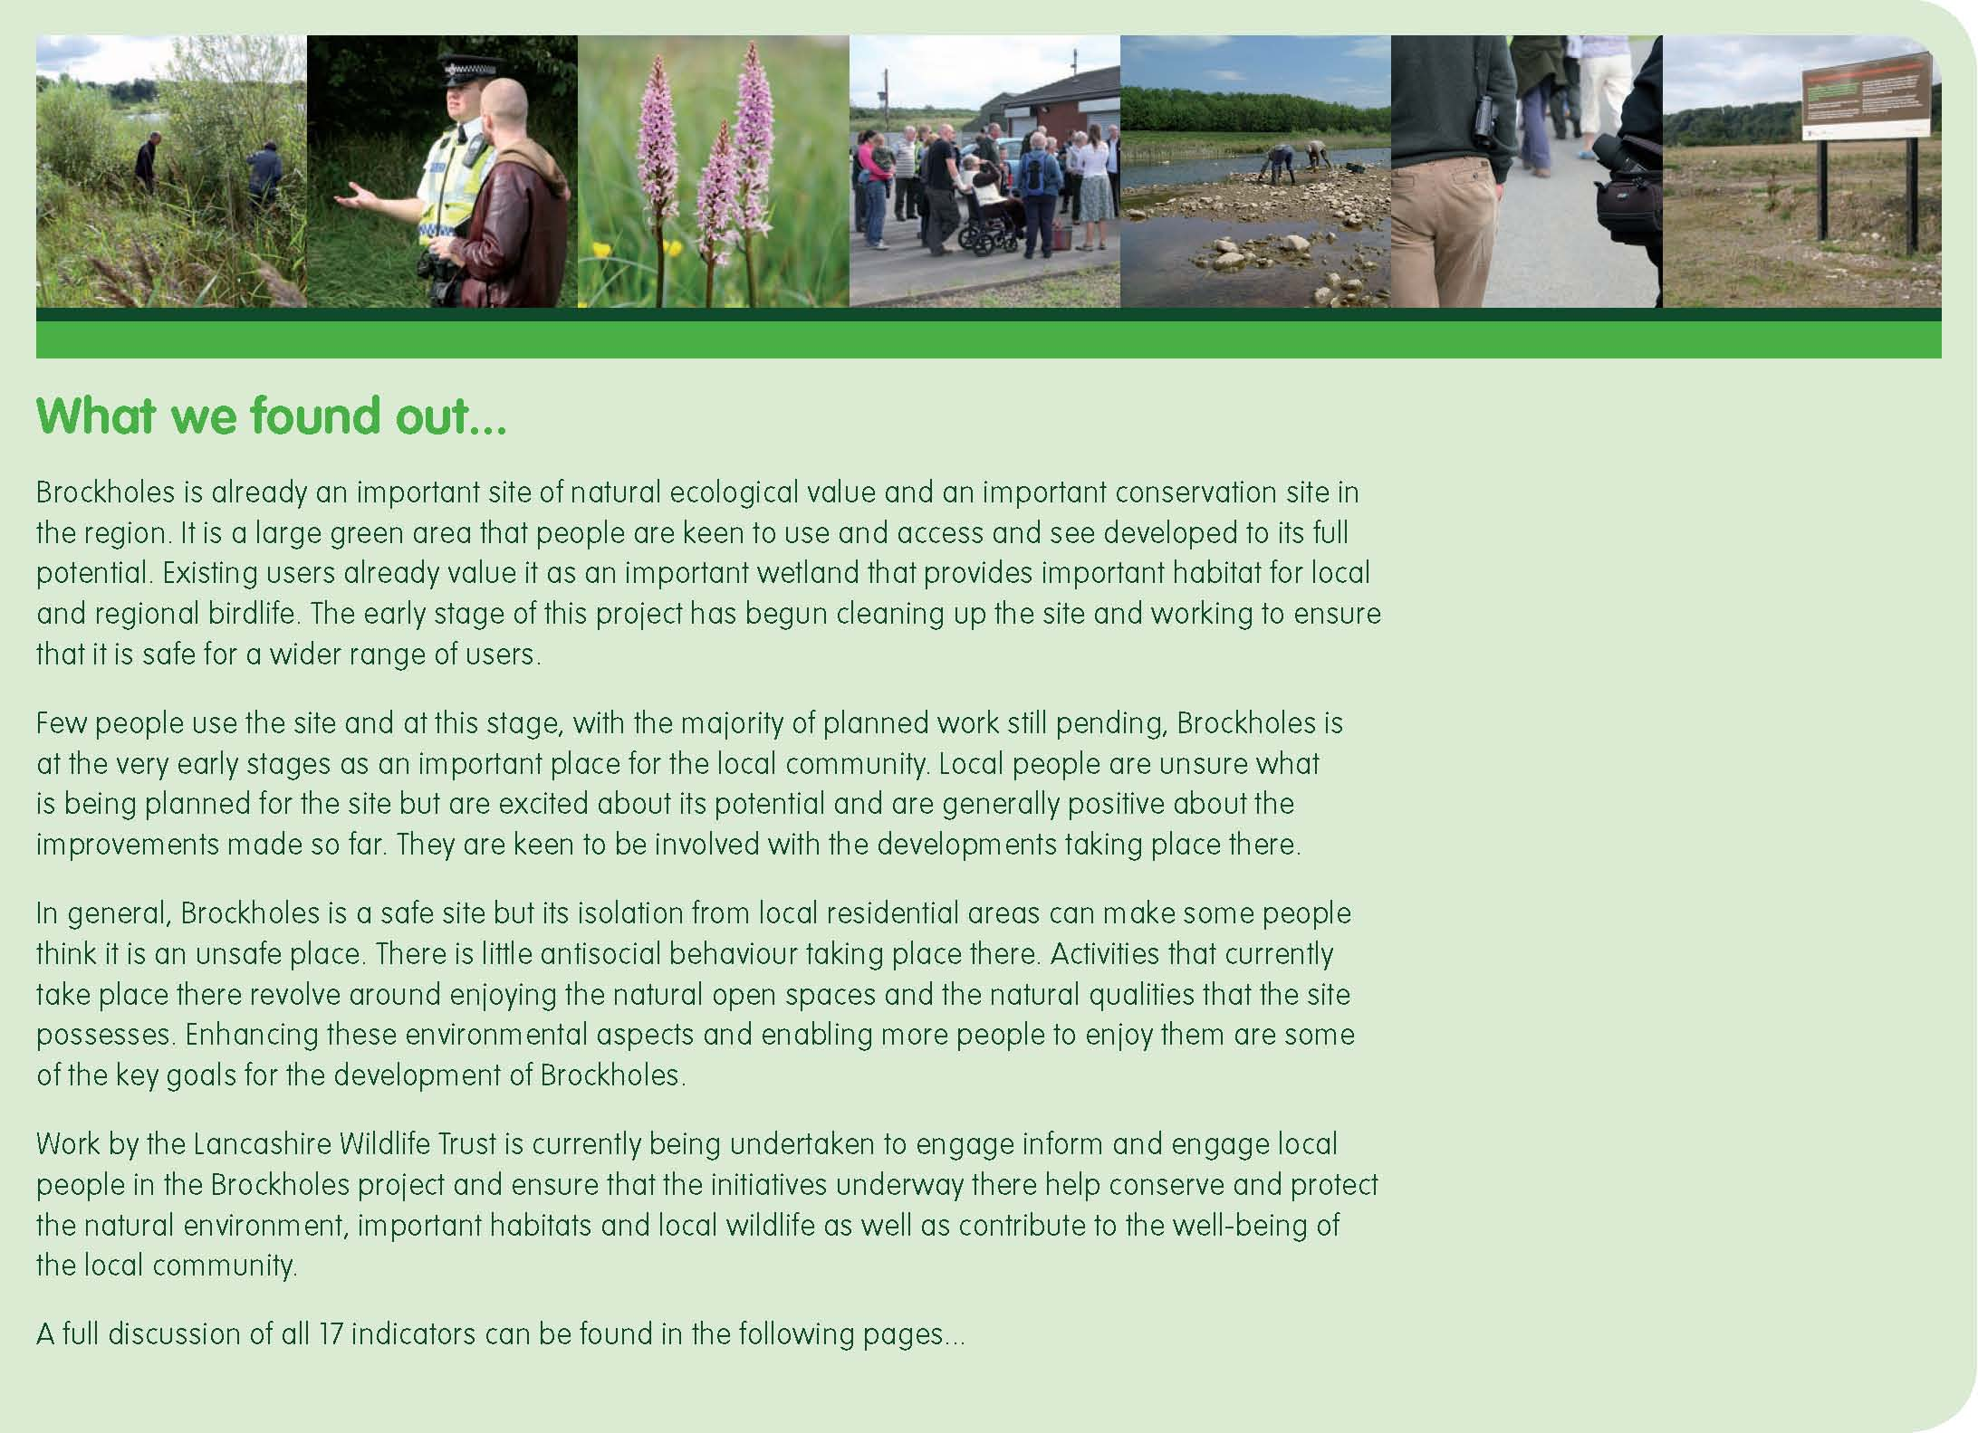
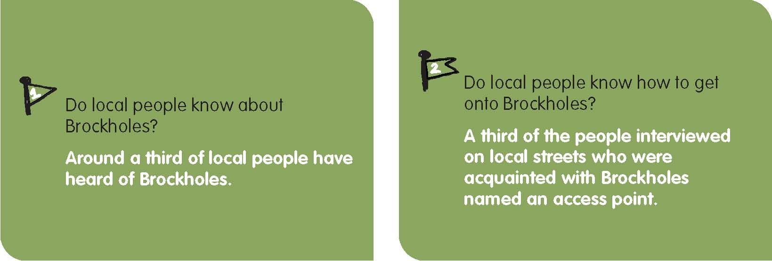
Brockholes is situated in a predominately rural area and few people live close to the site. Therefore, to conduct the on-the-streets research, attention was focused on the nearby village of Samlesbury and the estates west of the motorway (these included Ribbleton Hall and the area around New Hall Lane.) Researchers reported emptier streets than around other Newland sites and a shortage of community infrastructure, like libraries and shopping centres, around which people tend to gather.
In all researchers interviewed 187 people on local streets. Of the 187 people interviewed on local streets, 63 people (34%) had heard of Brockholes. This must be considered in the context that the closest residential areas are at least a twenty minute walk from the site across the M6 motorway. In addition to this, until recently the Brockholes site was a working gravel extraction site with limited public access. Also, some people who said they knew Brockholes might have been thinking of the nearby Brockholes wood that backs on to the local housing estate and is well used by local residents. Overall therefore we consider that 34% of people having heard of Brockholes is encouraging and may reﬂect the community outreach work that Lancashire Wildlife Trust has been doing around the site in the last year.
The only way local people can currently access the site by foot is by crossing the motorway on Pope Lane and coming into the site by Bolton Wood on the north end of Brockholes. Vehicular access is at the south end of the site and under the motorway. This access point is not signed and not encouraged at the present time, as the site is not ready to take unsupervised visitors.
It is therefore not surprising that of the 63 people interviewed on the streets who said they had heard of Brockholes, only 20 (32%) could actually name an access point. Of these 20, 17 of them (85%) said they crossed the motorway by foot at Pope Lane and walked through the woods to get to Brockholes. Of the 12 people interviewed on Brockholes itself, 7 had come through the main gate and not one had arrived via the motorway pedestrian bridge. Of all those people asked about Brockholes only 20 of 187 people (11%) interviewed could name an access point onto the site
When those interviewed on local streets were asked “Does anything stop you using Brockholes?” 27% of the 69 respondents mentioned issues around access such as steep pathways and blocked entrances. Another 27% said that nothing stopped them using it. Anecdotal evidence from the Spaceshaper event showed that those that knew the site found it easy to access. In addition, those that hadn’t visited Brockholes before felt that they now would ﬁnd the site easy to access in the future. As a result, 17 of the 22 attending the Spaceshaper event broadly agreed with the statement “I can get here easily”.
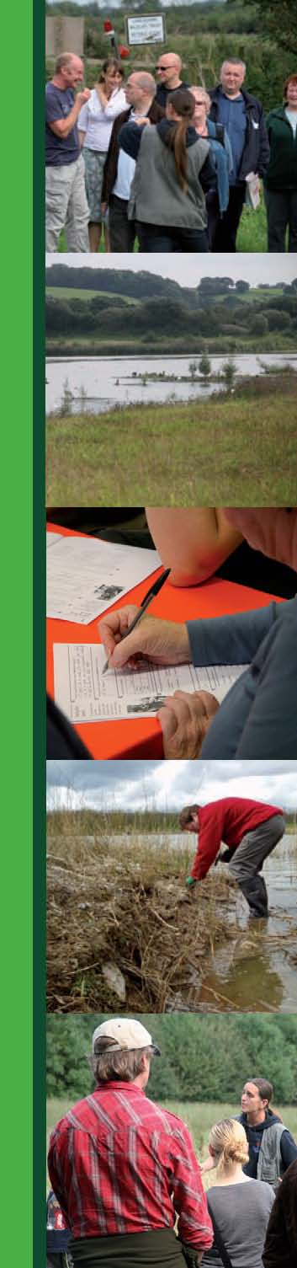
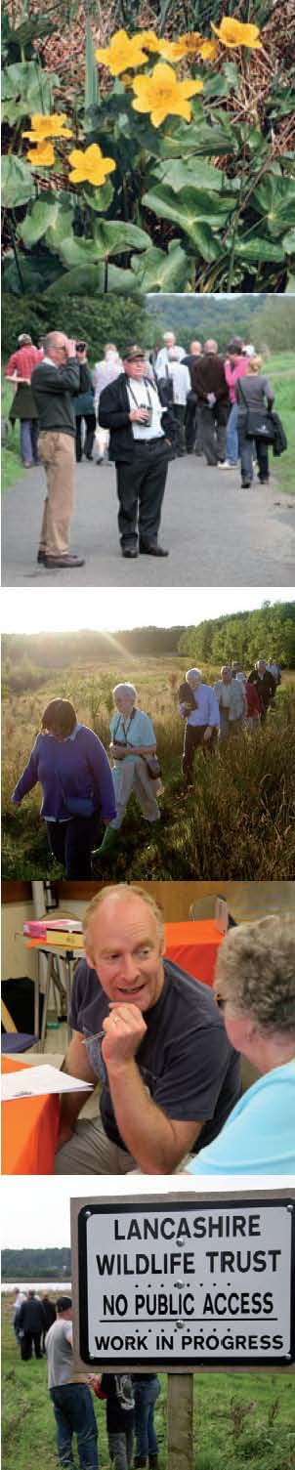
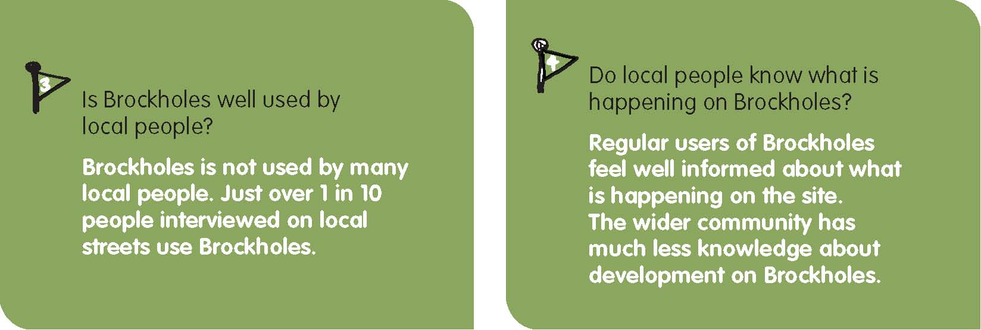
Of the 187 people interviewed on local streets, 23 people said they do go onto Brockholes. This represents just 12% of all those interviewed. This low percentage is unsurprising given the fact that at this stage the site has had little development and is not encouraging public use. Currently, activities such as walking, bird-watching, canoeing or ﬁshing appear to be the main things that people do on the site. For example, when we asked those that use Brockholes what they do there, 39% of people said they went for a walk or walked the dog. More recreational activities such as picnicking or playing are not really feasible at this stage.
From observation and evidence from the Lancashire Wildlife Staff, current users of Brockholes includes staff and volunteers working on the project, anglers, bird watchers and dog walkers who have used the site for years
– even before when it was a gravel extraction site. The site is well known as an important bird watching location.
Of the 35 people who say they use Brockholes (23 people on the streets and 12 people interviewed on the site itself), 18 use it often (weekly or more) and 15 use it occasionally (once a month or less). When people on local streets were asked “Does anything stop you using Brockholes” the only signiﬁcant issues raised were access and safety. The site is isolated and has few users at the moment.
The participants at the Spaceshaper event included 4 people who worked on Brockholes; 10 people who knew the site (5 who use the site every day or once a week and 5 who use it only very occasionally) and 8 who had never been to the site before the Spaceshaper event. These groups responded very differently to the Spaceshaper statement of to what extent they felt they knew what was happening on the site. All the workers felt they knew what was happening on the site. Seven of the ten people who use the site felt they knew what was happening on Brockholes and only 2 of the 8 people new to the site could agree with the statement ‘I know what goes on here.”
In the general discussion at the Spaceshaper event it was agreed that the wider community probably had a poor knowledge of what was happening on Brockholes. It was felt that a ‘Friends of Brockholes Wetland and Woodland Nature Reserve’ group would be a useful step in providing a clear source of information about the site and a way in which local people could become further engaged in the developments taking place there.
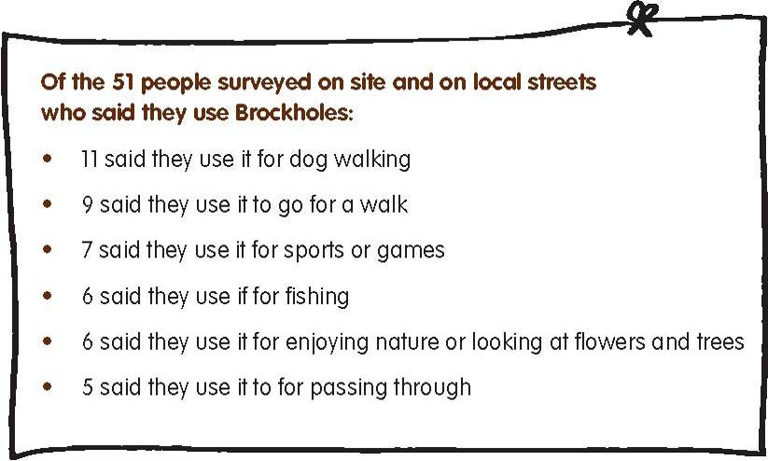
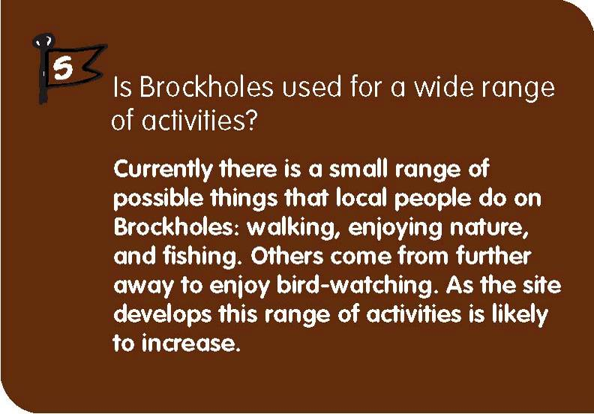
Of the 199 people surveyed on Brockholes and on local streets, 51 said they used Brockholes. These people said they mostly used Brockholes for dog walking and walking.
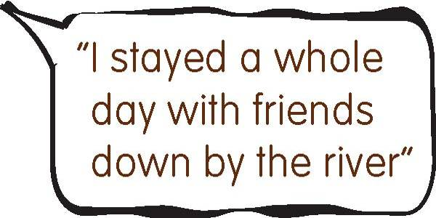
Three Spaceshaper statements relate to the issue of whether Brockholes is used for a wide enough range of activities. These are: “I can do what I like here”; “This place has all I need” and “There are lots of different activities going on here”. Broadly 50 -60% of the users and potential users of the site agree with these statements and around 30% disagree. This indicates that the current sort of activities offered by Brockholes do satisfy a lot of users. However it also shows that there is a signiﬁcant number of people who wish to see a broader range of activities on the site. Achieving a balance between current and future demands will be a challenge for the management of Brockholes.
This issue was explored in the discussions at the Spaceshaper day, and in the main people felt the current scope of activities should be expanded. Other activities people would like to see on Brockholes include: activities for children, arts and cultural events, guided activities likes bat walks, educational activities to help people learn more about wildlife and nature conservation, and activities to attract people from minority ethnic groups. In addition a small number of people expressed the wish for the site to be left largely untouched as they already value the peacefulness and solitude to be found there.
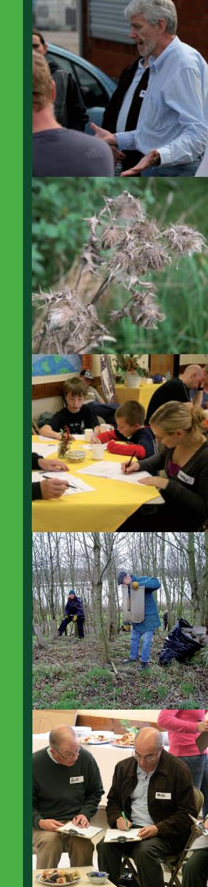
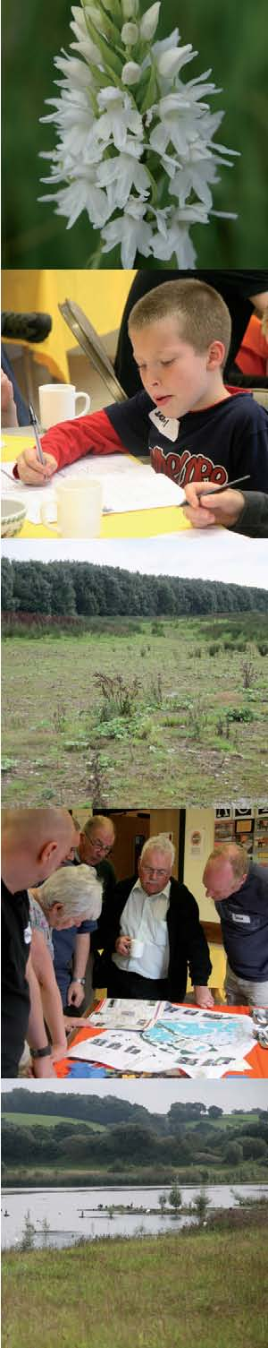
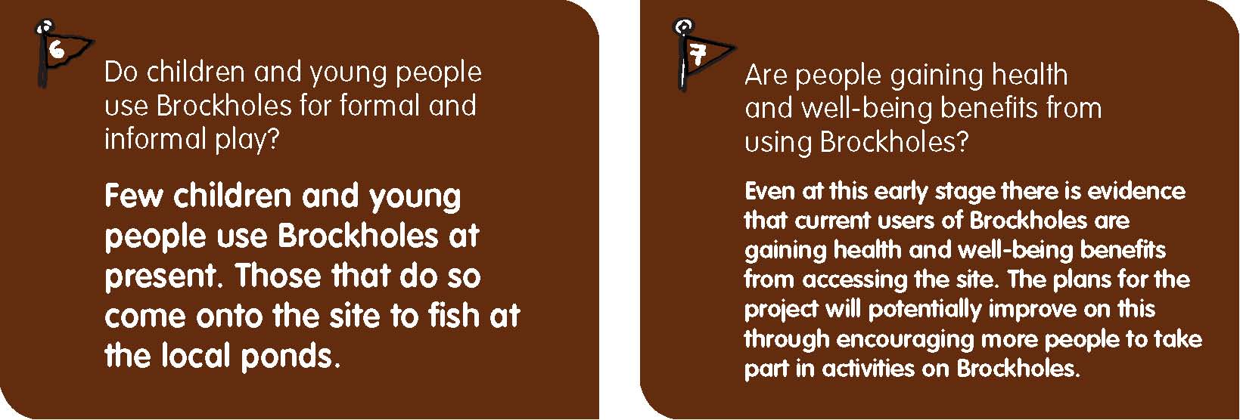
A dawn to dusk survey was undertaken on Brockholes on both a week and weekend day. A total of 63 people were observed using the site on the week day. None of those observed were thought to be under 19 years of age. This is to be expected as most children would be in school for much of the time the survey was undertaken. However on a weekend day, 49 people were observed using the site and 7 were children or young people. It is hoped that as the site is developed, younger people will also be encouraged to use the site and enjoy activities there.
Brockholes is also being used by Lancashire County Council youth outreach workers, who are engaging local young people in ﬁshing activities. So far in its early stages this program has proved successful and there are plans for it to continue. There are plans for formal play facilities for young people and children close to the new visitor centre.
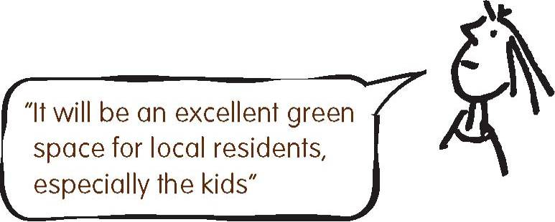
Those local people who use Brockholes currently are using it for health promoting activities. In particular, the site is popular with local people for walking and dog walking with 39% of respondents naming these as activities they undertake on Brockholes.
There are also important potential beneﬁts for people’s well-being. The close proximity of a large, natural, open space can give local people the chance to relax and de-stress. Of the 44 respondents on local streets to the survey question “What do you like about Brockholes?” 22 (50%) said that they valued the wildlife found there as well as the natural feel and tranquillity of the location.
Overall then, users of Brockholes are gaining health and well-being beneﬁts from Brockholes through using the site for activities that reﬂect the highly valued ecological importance of the site and its appreciation as an important natural green space close to local communities. Increased usage and improvements to the site will enable more people to experience Brockholes.
Responses from Spaceshaper participants who use Brockholes highlight a similar perspective. The following are some of their responses to statements in the questionnaire:

100% agreed that ‘I can relax here’.
96% agreed that ‘This space makes me feel good’
96% agreed that ‘I can enjoy nature here’.
91% agreed that ‘This space helps me to be healthy’

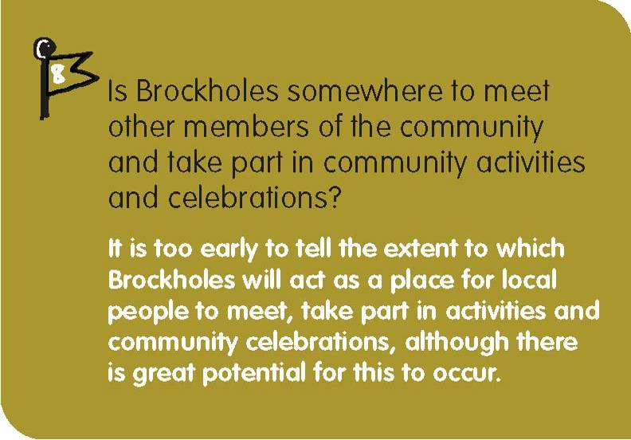
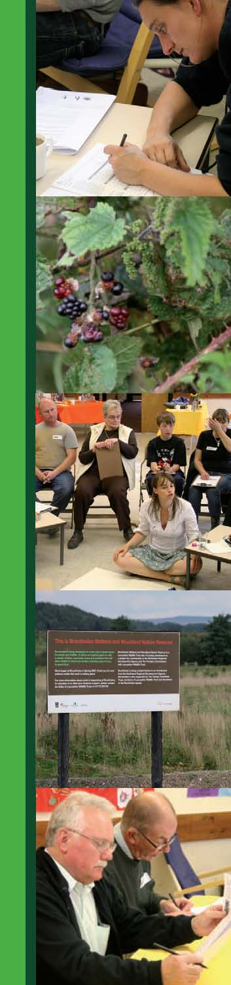
The primary goal of Brockholes Wetland and Woodland Nature Reserve is to be a major nature conservation site of regional and national importance. It will have a staffed visitor centre and be able to run and support a range of engagement activities for the community in the future. Any community activities are likely to stem from and serve its overriding objective and will therefore have an ecological and conservation focus. In addition the ‘community’ that Brockholes serves also includes visitors from the region and beyond especially as it will have the potential to be major ‘rest’ destination on routes up and down the M6 motorway.
Currently the site is not in a condition to support community activities and it will take a couple of years to get to this position. For example substantial works will start in 2009 and building commences on the visitor centre in August 2009 and will take over a year to complete. Also, more development will take place around the ﬁshing ponds to
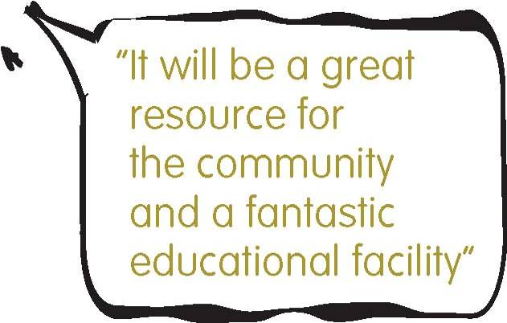
make them more accessible to anglers and for angling activities. It is therefore too early to tell the extent to which Brockholes will act a place for local people to meet, take part in activities and community celebrations. The extensive work done by staff on site to develop links with the local community will prove important in making decisions about the ways in which the local community are involved in and engage with the Brockholes project.
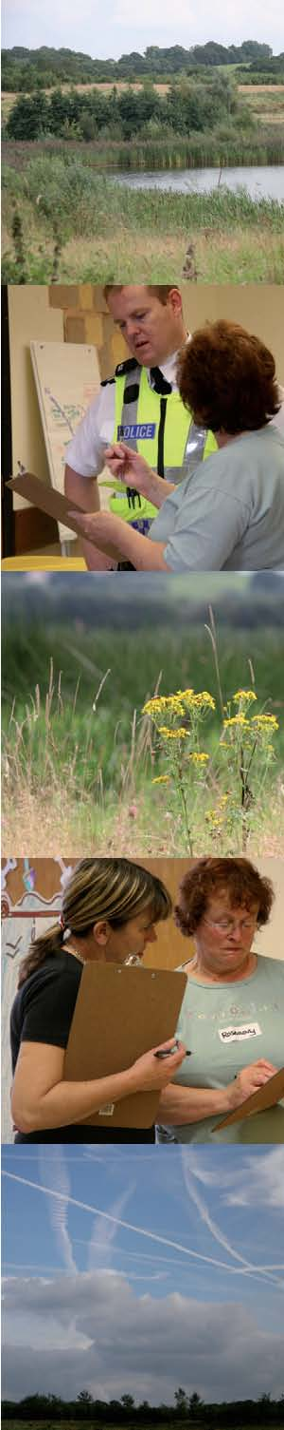
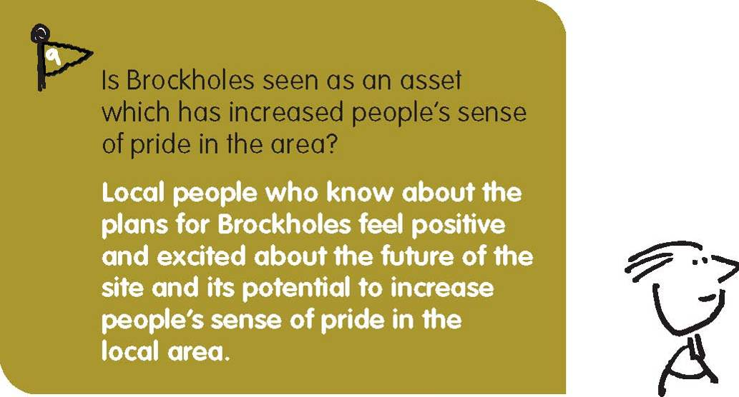
At the Spaceshaper event 20 of the 22 participants (91%) agreed with the statement that “This place improves the look of the local area” and all the participants agreed with the statement that “This space is important to the local area.” In discussions that followed it was clear that people had answered this question for the site as they hoped it would be. As such, while there are users of the site who are already proud of Brockholes as it is as an important ecological site, participants were equally excited about plans for Brockholes and conﬁdent it would be a resource which would increase the community’s sense of pride in the area.
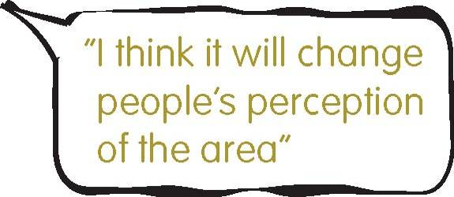
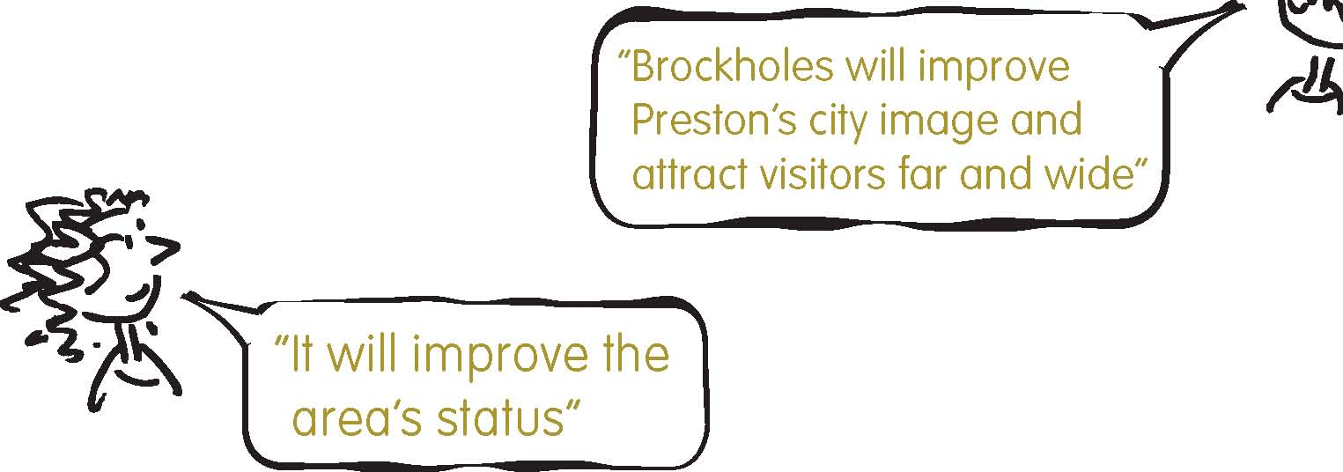
At present the site makes a vital contribution to the local environment in terms of the habitat importance to local and regional birdlife. In terms of the environmental importance for the local community it is yet to fulﬁll its potential and it is hoped that the developments taking place over the next few years will see Brockholes also become an important part of the community’s local environment. It is envisaged that the Brockholes Wetland and Woodland Nature reserve will play a major role in environmental and conservation ‘infrastructure’ in the area.
Along with nearby woodlands and wetlands, the Lancashire Wildlife Trust highlights the importance of these connected areas as “the largest complex of semi natural ancient woodland in the Lancashire Plains and Valleys Natural Area”. The improvements to this important wildlife habitat will also contribute to the protection of local species and the biodiversity found in the area. Improvements to the site such as better access and paths, the support of recreational use on the water bodies on site, small scale recreational use facilities and the development of educational and training facilities will all contribute to enabling a wide range of people to enjoy this nature conservation area.
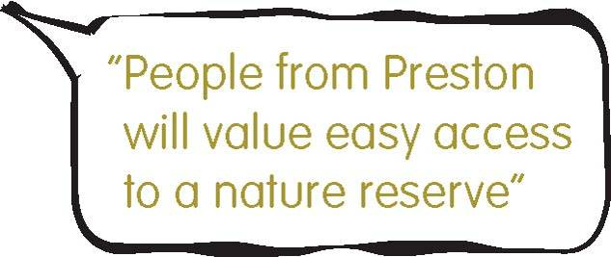
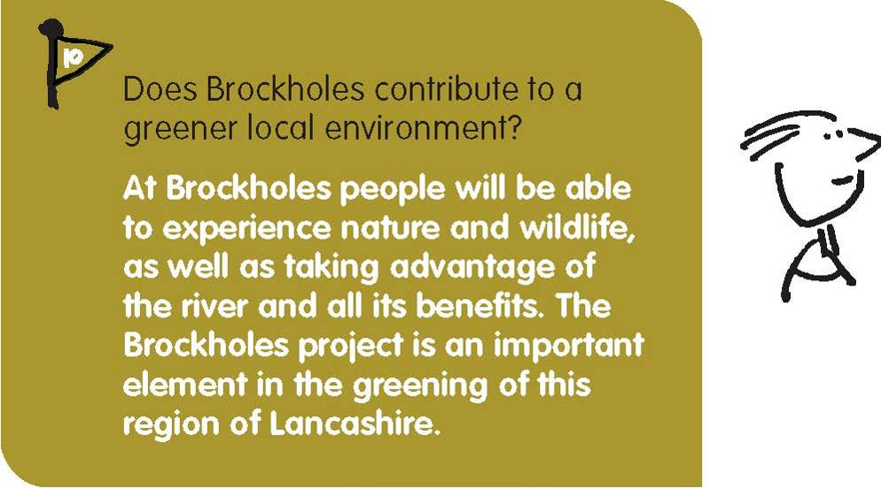
It is also worthy of note that in addition to the site’s potential to contribute to the local green environment Brockholes has great potential to contribute to the regional ‘blue’ infrastructure through increased use of the local River Ribble and building on the already existing importance of the site as an important bird-watching location. When people on local streets and on site were asked about their most recent visit to the site, a quarter of the 32 respondents mentioned the river and the ponds as part of their visit.
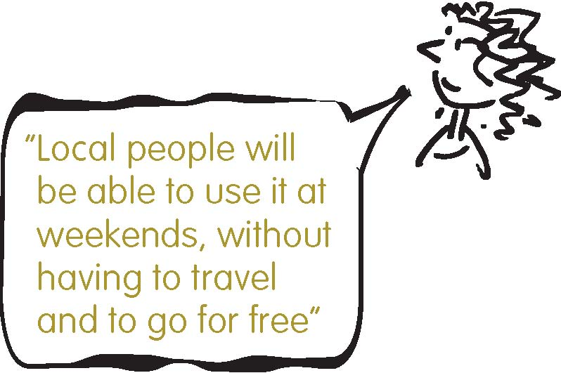
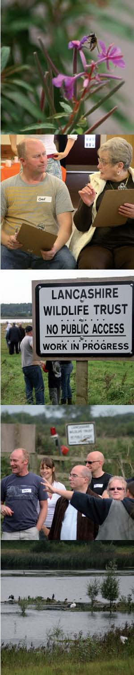
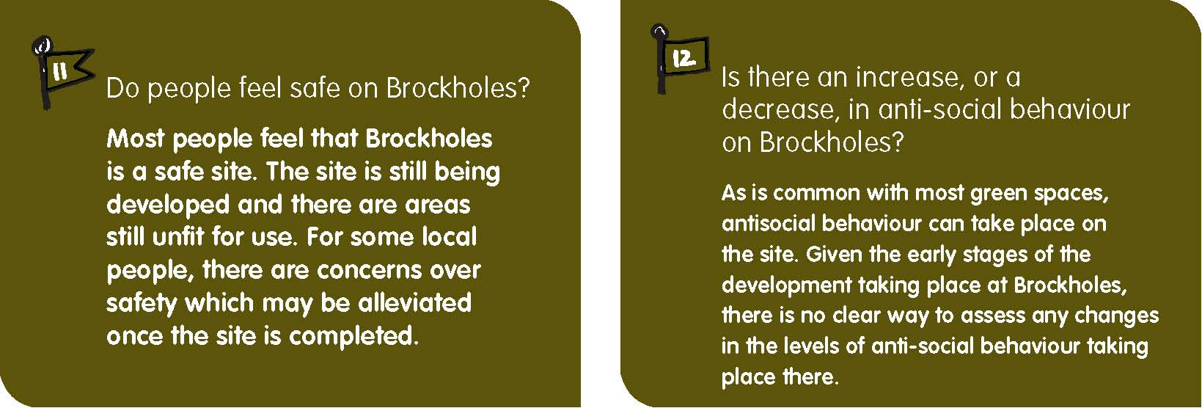
In general Brockholes is perceived as a safe site. When people were asked on local streets and on site what factors stopped them from using the site 19 of the 69 respondents (27%) said that nothing stopped them while 19 (27%) said that access was the main issue. The issue of safety and security were raised by 16 of the 69 respondents (21%). Those that use the site from the local area do so in relatively informal ways given that the site is not yet completed and there are still improvements to be made in terms of access, mobility and security on site.
At the same time 77% of the 22 Spaceshaper respondents broadly agreed with the statement ‘I feel safe here’. This is most likely made up of those users who do visit the site and feel safe on it and those people who were visiting the site for the ﬁrst time and giving their views on how they perceived the site on that day. What this suggests is that those familiar with the site are comfortable in using it in safety and the initial impressions of those visiting for the ﬁrst time were positive in terms of a sense of safety. But there were concerns that there is a wider perception within the local community that at this stage Brockholes can be an unsafe place to visit given that it is not completed and there are few people around on the site at this stage. Developments taking place on Brockholes will impact on perceived levels of safety and these will need to be assessed in an ongoing manner in order to ensure the safety of users.
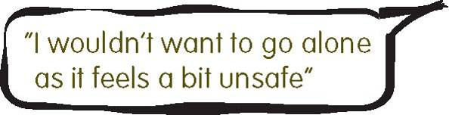
At this stage it is impossible to assess if there has been any increases or decreases in anti-social behaviour taking place on the Brockholes site. Discussions with Lancashire Wildlife Staff on site point to there being only minimal amounts of behaviour on site that could be deﬁned as antisocial. At this stage, while there is no ofﬁcial incident log for anti social behavior at Brockholes, on-site staff indicates that in the time the site has been their responsibility there has been only two minor instances of antisocial behavior. While motorbike use is common on green spaces to the north of Brockholes there have been few occasions when they have been introduced to the Brockholes site.
In terms of using the site, when local people were asked what might stop them from using the site, 6 of the 69 respondents (9%) mentioned nuisance motorbikes and 8 people (12%) mentioned general issues of safety and the site as being ‘dangerous’. In part this probably stems from the isolated nature of the Brockholes site.
Given the low numbers of people currently visiting Brockholes the current low levels of reported anti-social behaviour are not surprising. However, information from the local police indicates that it is possible that antisocial behaviour and crime may rise as the proﬁle of the site itself is raised. The isolated nature of the site may also be an issue in the future. Learning from issues that are already present on other local green spaces that Lancashire Wildlife Trust are involved with will be important factors in collaborating with local authorities and communities in ensuring the site is safe and feels safe for all users.
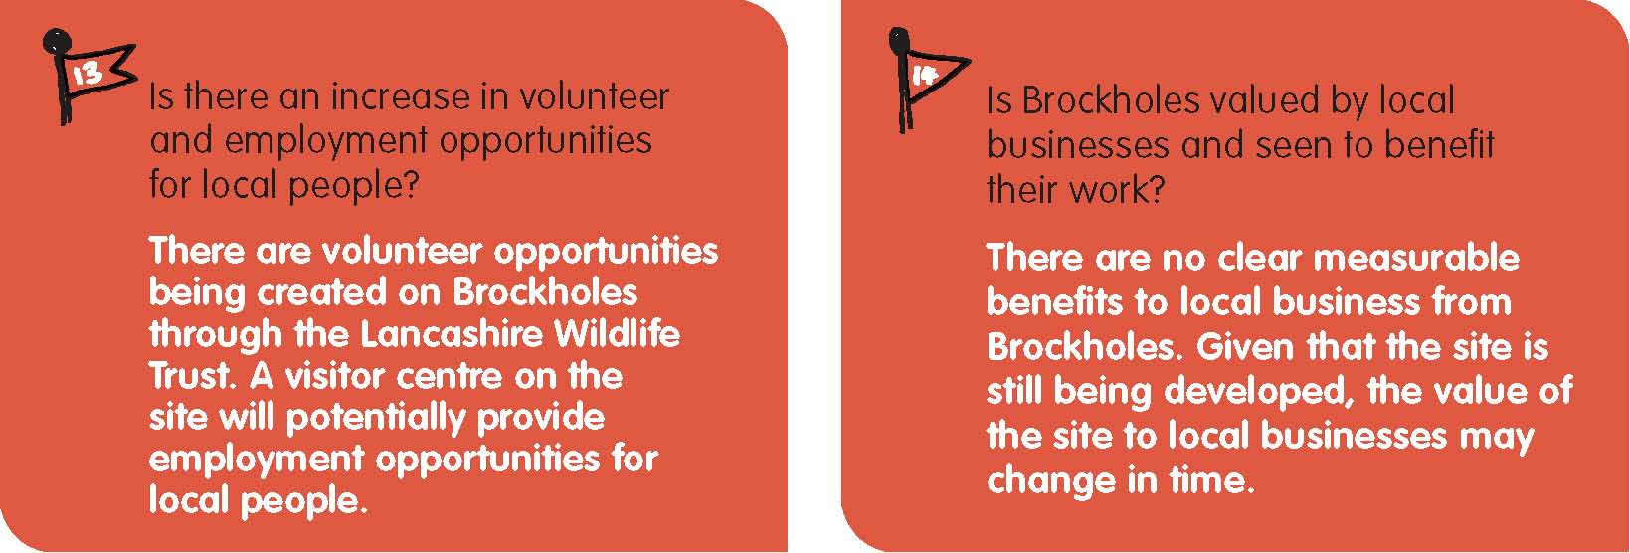
Considering that Brockholes is very much at the early stages of being developed there has been an encouraging amount of opportunities for volunteers to get involved. The Lancashire Wildlife Trust has recruited volunteers through the local press and local community groups. They have begun working with volunteers primarily in habitat creation and nature conservation as part of the redevelopment of the Brockholes Wetland and Woodland Nature Reserve. It is expected that these volunteering opportunities will grow over time as the site develops and improves.
Employment opportunities at this time are restricted as the site is still ‘under construction’. But the visitor centre that will be constructed for the site and the commercial plans based on its presence will generate employment opportunities for the local community. Also, the vision plan for the site includes the introduction of apprenticeship schemes for biodiversity managers which may enable local people to become more involved in the maintenance of the Brockholes environment.
Brockholes is situated at some distance from any local businesses. With very little commercial enterprise near the site and the fact that the Brockholes is still a relatively unknown destination, it is not clear what beneﬁts the ﬁnal development may bring to the local economy. It has, therefore, been difﬁcult to assess whether Brockholes is valued by local business. Future discussions with businesses in nearby estates and at the Red Scar Industrial Park will be important in assessing the opinions of the site from local businesses and the impacts it has on their businesses.
When ten local businesses were asked about the Brockholes project only one said that they or their staff used the site. And only one respondent (a local ﬁshing supplies store) felt that the site will be of beneﬁt in the future. When asked what would encourage them to use Brockholes, four of the ten mentioned that they would visit it when they knew more about it, when they felt it was safe, and when there was ‘something to see’.
Participants at the Spaceshaper event mirrored this uncertainty. In response to the statement ‘this place is good for local businesses’ 8 participants (36%) broadly agreed, 8 (36%) broadly disagreed and 6 (27%) felt that they did not know or were unable to make a comment. Some of these responses may reﬂect the opinion of those people thinking more of future beneﬁt (or lack of) to local businesses of the developments at Brockholes. For some participants, the beneﬁts to local businesses are secondary concerns after the environmental and community beneﬁts that the improvements may bring to the local community.
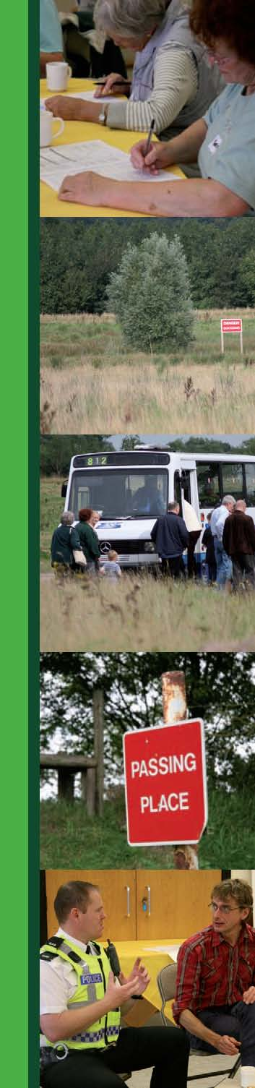
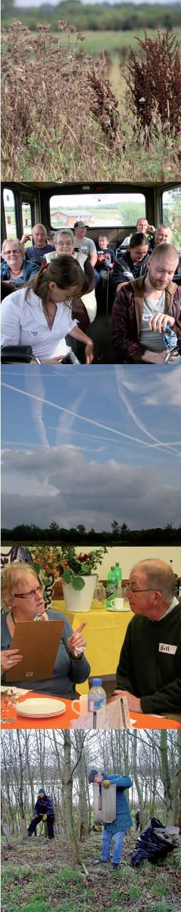
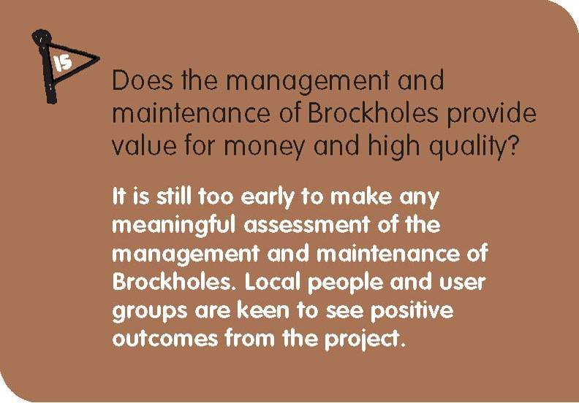
The improvements to Brockholes are still being implemented and the transformation of the area will continue to evolve. At this early stage of the Brockholes project there is little hard data to assess the quality and value for money that the management and maintenance of the site represent.
What is clear is that maintenance of the site is an issue as much for local users of the site as for those user groups (not necessarily from the local community) accessing the site for its ecological value. Both user groups are important stakeholders in guiding the future management and maintenance strategies on Brockholes. The Lancashire Wildlife Trust is the lead body in the management and maintenance of the Brockholes project. Workers are on the site daily and are engaging with the local community about the plans for the site. A substantial level of investment is being directed towards cleaning up the site, making it safe for use by the general public and creating a regionally important wetland and nature reserve.
In discussions at the Spaceshaper event it was evident that people generally felt that the Brockholes site is well maintained with 73% of participants broadly agreeing with the statement ‘this place is clean’. A lower but still signiﬁcant 59% broadly agreed that ‘this space is well looked after’. Given that there is still much work to do, and that the major works are still pending, this is an encouraging response to build upon.
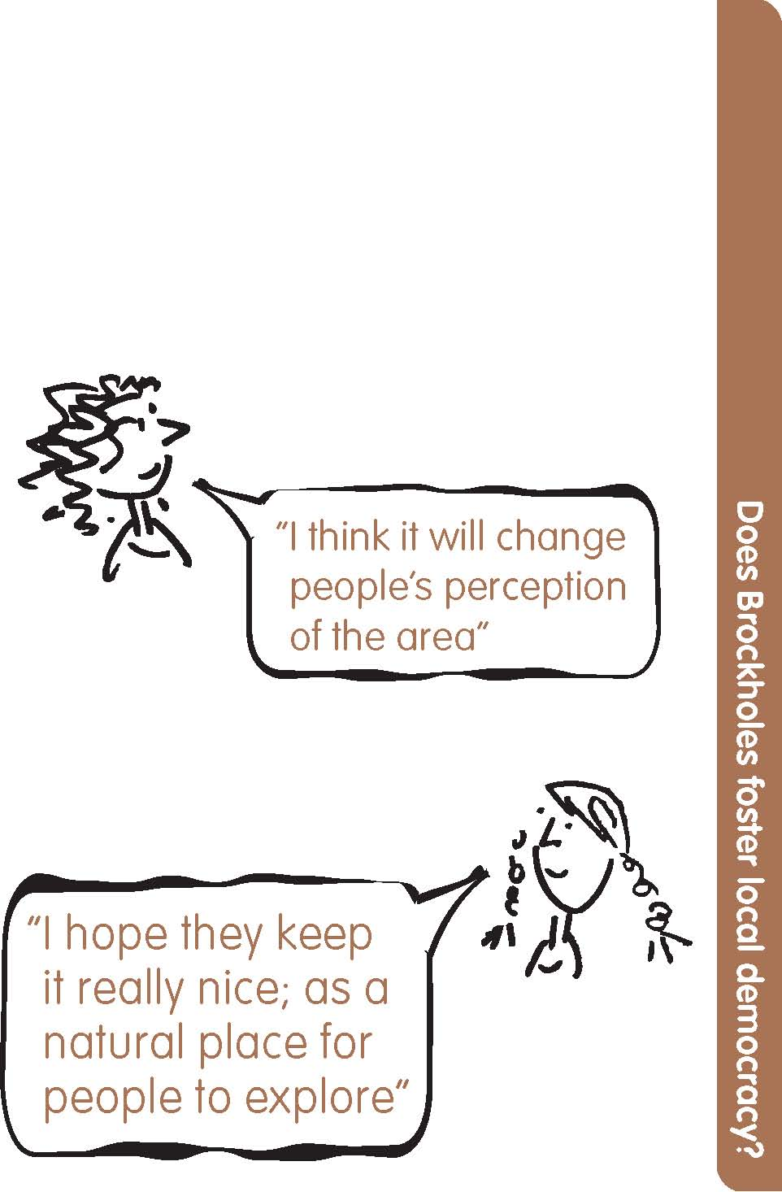
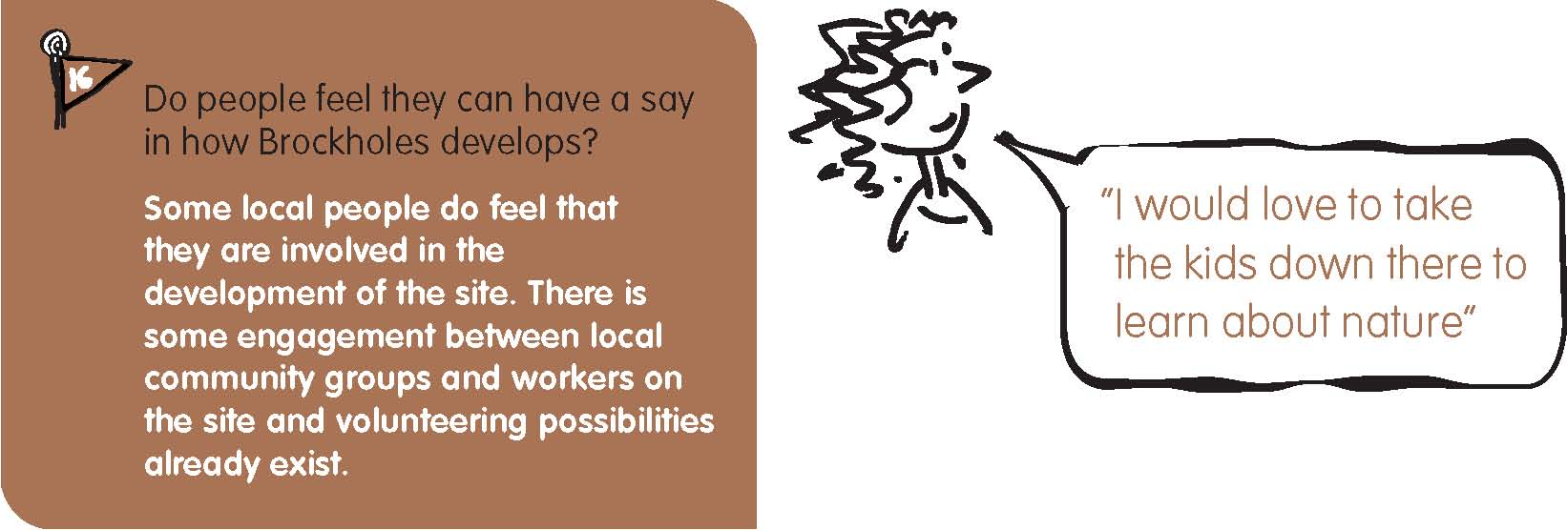
Brockholes Wetland and Woodland Nature Reserve is a site under development and some local user groups in the area have been and are actively involved in the site via the Lancashire Wildlife Trust and its engagement with community members and volunteers in habitat creation. There has been less consultation with the residents in the local community at this stage in regards to gaining their input in the development of the site but there are plans to involve local people in future activities. Local workers on the site itself have been engaging with the local communities near to the site as they seek to build awareness of the project and develop contacts locally to engage the local community in the use of the new Brockholes project area.
Encouragingly, 73% of Spaceshaper respondents felt that ‘the people who live around here are involved in the running this place’. So while there is a feeling that local people are involved in the site there was also some disappointment expressed that this has commenced after the planning phase of the project has been completed. Nevertheless, there are still important contributions that the local community can make to the success of the Brockholes site and the groundwork already achieved by local workers will be an important basis on which to construct meaningful collaborations with the local residents and groups in the future. There are a number of active community organisations in the nearby estates who have already been discussing the site with the Lancashire Wildlife Trust.
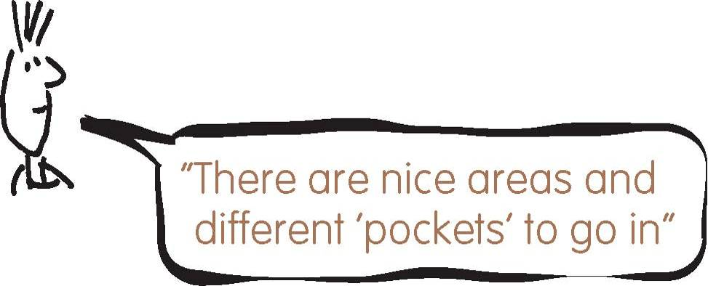
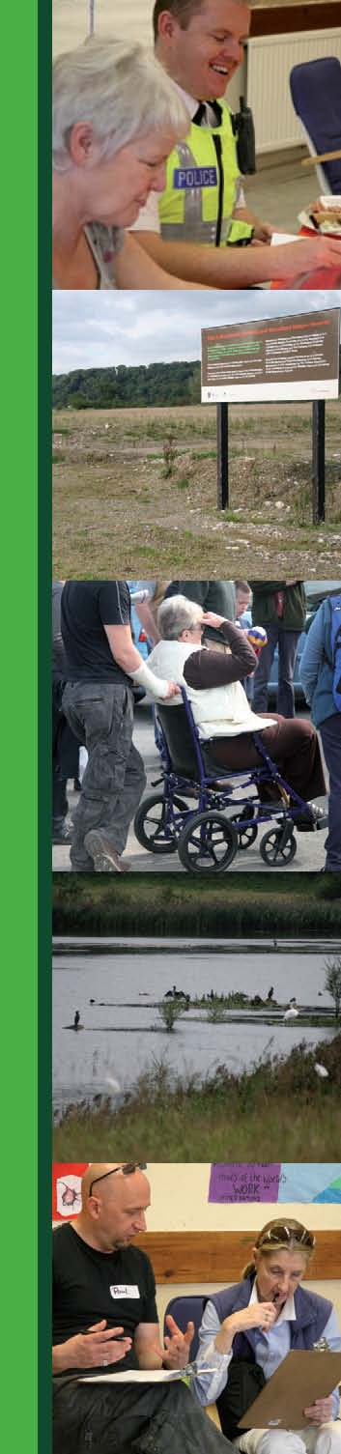
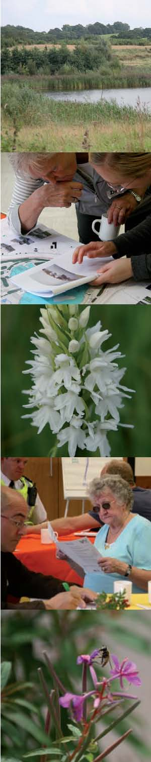
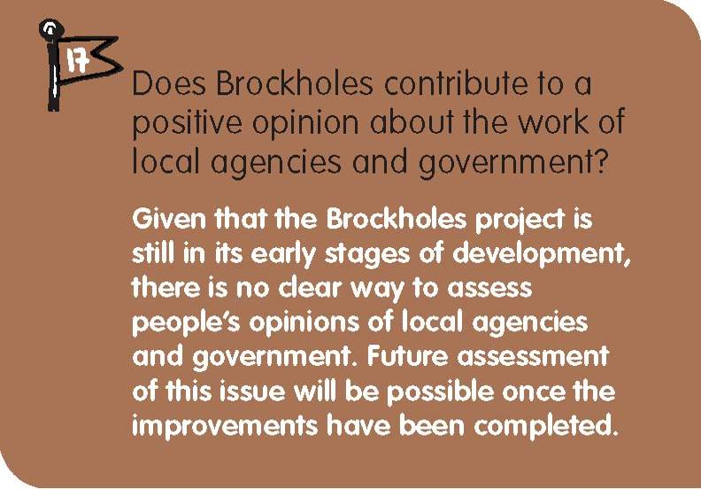
Local people and users of the site appear to welcome the work being undertaken by the Lancashire Wildlife Trust and the Forestry Commission on the Brockholes site. At this early stage there is little meaningful data that could be used to assess local opinions on local agencies and government. But given that the site is a former quarry site and lay relatively neglected for years, the improvements to Brockholes are likely to contribute to a positive opinion about those groups involved.
Approximately 73% of Spaceshaper participants broadly agreed with the statement that “this space has been made well”. This response may be inﬂuenced by the number of people that were not acquainted with the site until their visit during this event. But regardless, this response indicates an appreciation of the site. Improvements to the Brockholes project location have the potential to reﬂect well on those agencies involved in its development. There was a sense of disappointment from a few participants at the Spaceshaper event that there had not been any engagement with the local community prior to the conceptualisation and design of the space.
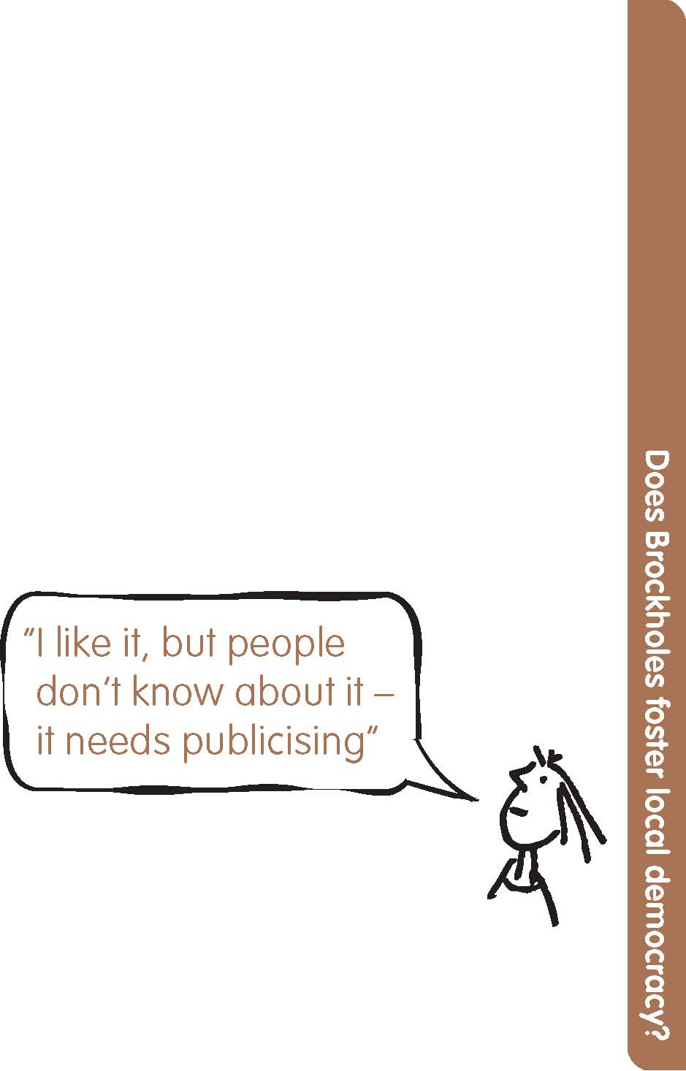
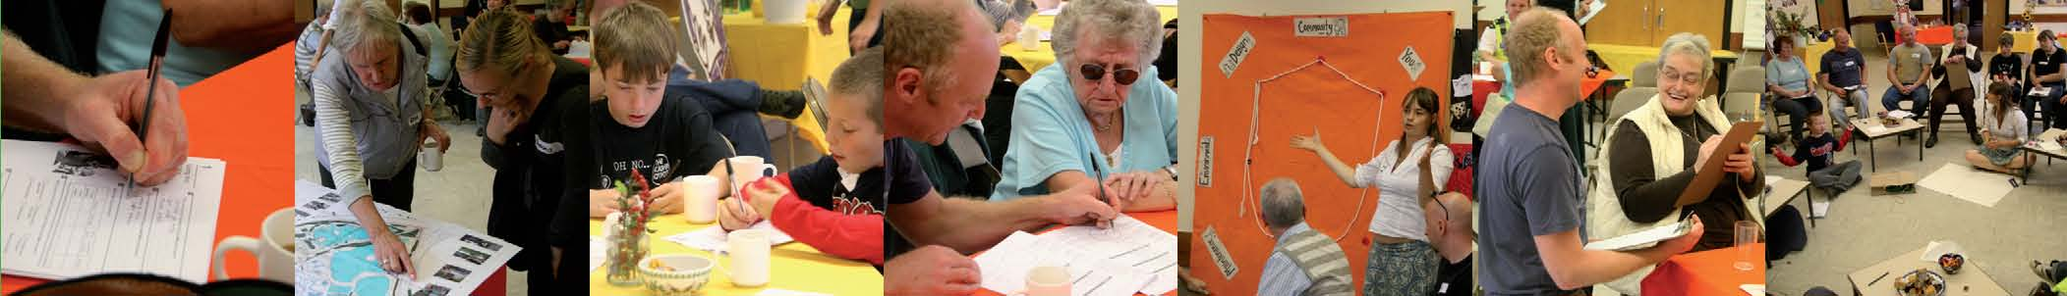
Feedback from the Spaceshaper event
A Spaceshaper event was held at The Farringdon Park Community Centre on Sunday the 14th of September 2008. Twenty two people participated and completed questionnaires. The event used Spaceshaper – a practical toolkit which helps people measures the quality of open spaces – to structure the discussions around the site and its future.
The Spaceshaper questionnaire asks 41 questions about an open space and the answers are grouped under eight headings. The results are shown in the ‘spider’s web’ diagram on the right. The solid black line shows the results for Belﬁeld. The dashed line shows how each of the eight issues would be in an average space. Results better than average are outside the dotted line and results less than average are inside it.
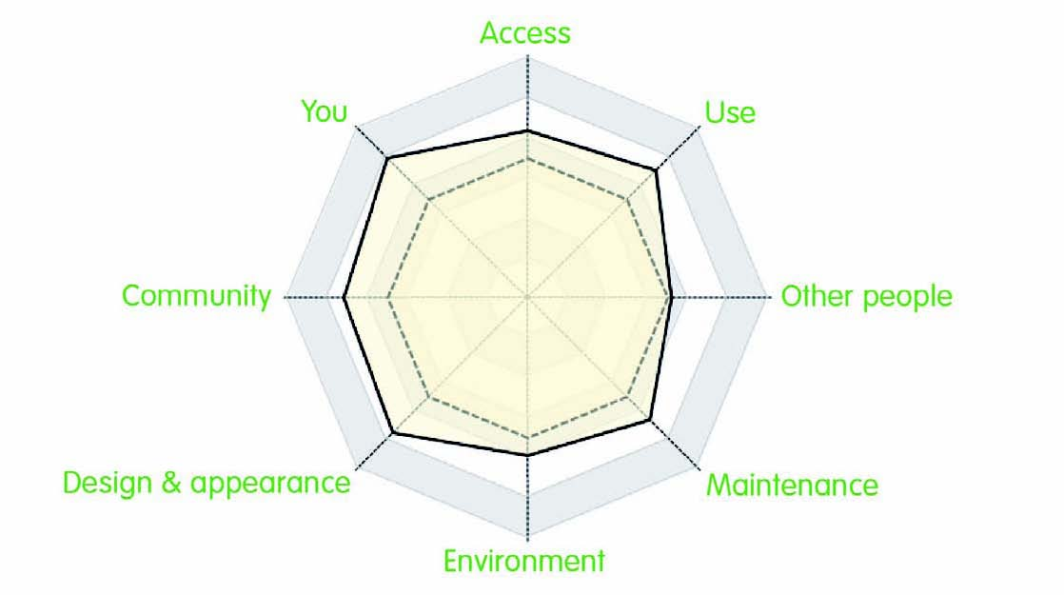
Overall, the result is positive for the future of Brockholes: the solid black line is outside the average line for all of the eight issues. There is clearly room for Brockholes to improve and these improvements are underway. If the site scored more highly in the future, then the solid black line will move outwards to the edges of the diagram.
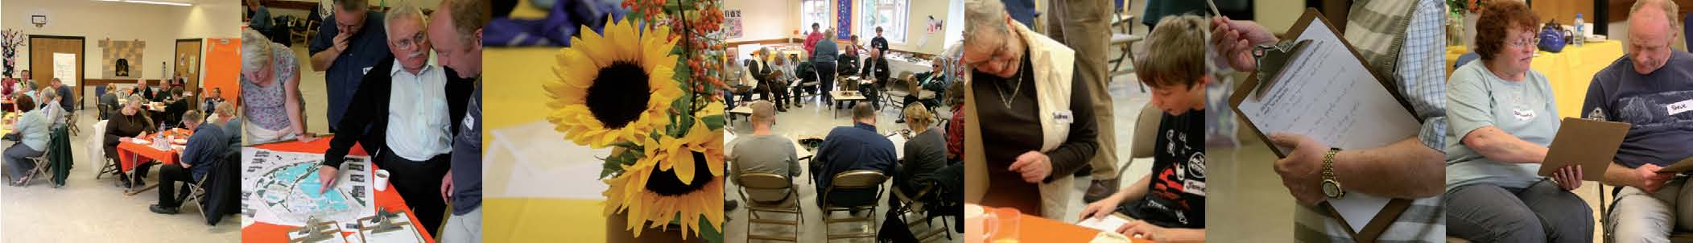
From the Spaceshaper diagram, it can be seen that those issues that scored extremely well are design and appearance, you, community and use:
Design and Appearance: The work at Brockholes has barely begun but there is already a clear value given to its appearance as a natural space. It will be important to build on these valued elements and improve those aspects that may increase the appreciation of Brockholes as a local community asset.
You: This was the aspect of the project area that received most agreement. For those already accessing Brockholes, it is a highly regarded area of conservation and natural green space. For newcomers there was a keen interest in the potential of Brockholes. They all have an interest in its future.
Community: Brockholes is a potentially important place for the local community and local people expressed keen interest in the future of the site and its impact on the local area.
Use: Those already using Brockholes enjoy the natural environment there and their use of the site reﬂects this conservation focus. There is a strong desire to enhance the ecological and environmental value of the site.
The issues of maintenance, access, and environment scored well and indicate key areas of desired improvement:
Environment: The development of the site and the new visitors centre will contribute to the already existing natural environment of the area by making Brockholes a safe and accessible place that can be visited and enjoyed year round.
Maintenance: As it is currently ‘under construction’, maintenance levels are not as high as they will be once Brockholes is fully developed and being used more widely. Maintenance of the site will be in the hands of the Lancashire Wildlife Trust and its workers and volunteers.
Access: At this stage there are only a few points of access to the site. The developments currently taking place will see better access and improved pathways that will enable better access to and around the site and enable more people to use Brockholes.
The issue of other people scored slightly above average:
Other people: This area received the lowest response and reﬂects the sense that few people at this stage are using Brockholes. Given the early stages of its development as a resource for the local area, this makes sense. People want to see the growth of current user groups as well as an increase in the diversity of people using Brockholes in the future.
Given that Brockholes is still in its early stages, the Spaceshaper event was as much an information sharing activity as it was useful for getting feedback from people that use the site and those that would like to use it in the future. There were two clear groups present: those working on and using Brockholes and those who didn’t know Brockholes at all. Those people who use the site for conservation-oriented activities already value Brockholes as an ecologically important location and gave their opinions on the current state of the site. Those who don’t use Brockholes are excited about the developments and are positive about the future of Brockholes and its impact on the local area. Their responses were more ‘aspirational’, focusing on the potential of Brockholes and their future use of it. The importance of building on the information sharing activities already instigated with these groups will be an important part of the process of involving local community members and key user groups in the future of Brockholes.
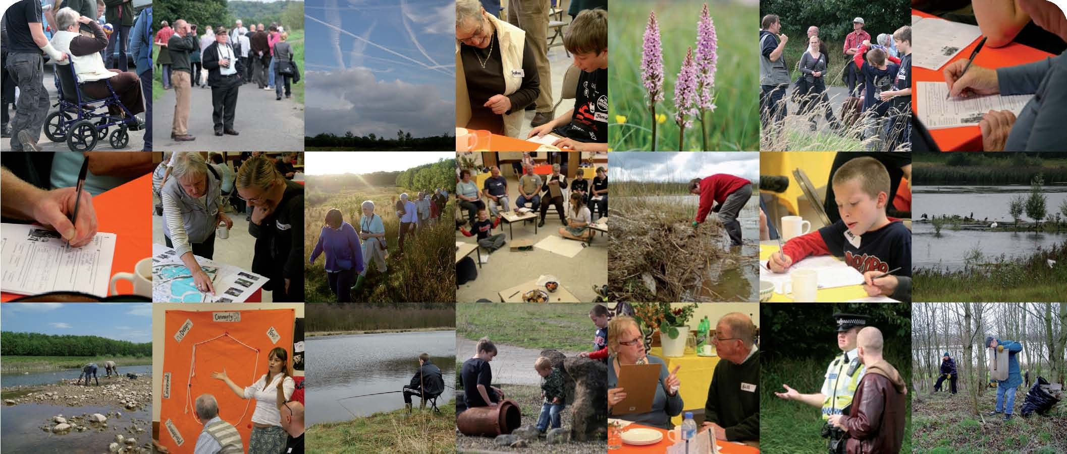
What happens next?
The information in this report establishes a baseline set of data for Brockholes Wetland and Woodland Nature Reserve in 2008. It tells how well Brockholes is performing at this stage in terms of its impact on the local community. The Brockholes development is just commencing and still to reach its full potential. All of the primary data that informs this report is held by the Forestry Commission and will be used by site managers to inform future work and research on Brockholes. Further research will be undertaken in ﬁve years time and information will again be gathered for each of the 17 indicators. At this point it will be possible to assess changes in the social impact of Brockholes.

